**Lab 1: Introduction to Tinkercad and LTspice, Voltage and Current Divisions**

In this introductory first lab, we will learn and familiarize ourselves with Tinkercad – a realistic circuit simulation tool. More importantly, we will also learn to use LTspice – a more abstract but more powerful simulation tool. We will build series and/or parallel resistor circuits, and gain some useful insights into voltage and current division rules (VDR and CDR). *LTspice work products will be graded. Tinkercad work products are optional only, and will not be graded.*

**Part 1_1: resistor in series, voltage division rule (VDR)**

***Lab_1_1_1 (first VDR circuit):*** construct this circuit with LTspice and Tinkercad (optional); the power supply (“source”) voltage = 10 V. Run LTspice with the operating point directive (.op), and write down the nodal voltages at Va and Vb, as well as the source current. With Tinkercad, use DMM to confirm that the power supply is actually providing 10 V.

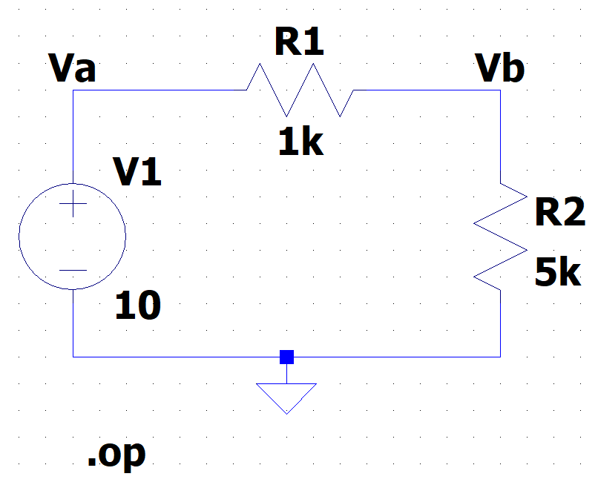

Fill out the following table to confirm the VDR

|  |  |
| --- | --- |
| V(R1) : V(R2) in Volt |  |
| R1: R2 in kOhm |  |
| Simplified ratio in integers |  |
| VDR confirmed (Y/N)? |  |

***Lab_1_1_2 (3-resistor VDR):*** construct the following circuit with Tinkercad and LTspice (for verification). Note that power supply = 20 V

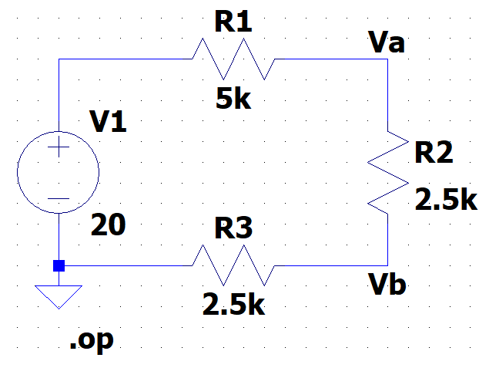

a) Use DMM to measure the total voltage and the individual voltages of R1, R2, and R3.

Fill out the following table to confirm the VDR

|  |  |
| --- | --- |
| V(R1) : V(R2) : V(R3) in Volt |  |
| R1: R2: R3 in kOhm |  |
| Simplified ratio in integers |  |
| VDR confirmed (Y/N)? |  |

**Part 1_2: resistor in parallel, current division rule (CDR)**

***Lab_1_2_1 (first CDR circuit):*** construct this circuit with LTspice and Tinkercad; source voltage = 10 V

Run LTspice, and write down the two branch currents I(R1) and I(R2), as well as the source current I(V1). They will be useful to check against the Tinkercad circuit measurements.

With Tinkercad (optional), use DMM to confirm that the power supply is actually providing 10 V.

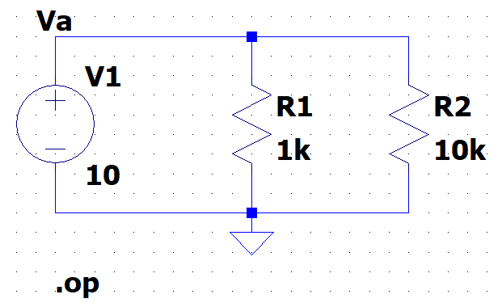

Record the current of each resistor – I(R1) and I(R2).

Then calculate the ratio of I(R1) to I(R2), and relate to the ratio of conductance 1/R1 to 1/R2

|  |  |
| --- | --- |
| I(R1) : I(R2); unit is in mA |  |
| Ratio of 1/R1 : 1/R2; unit is in mMoh |  |
| Simplified ratio in integers |  |

Write down the current division rule (CDR)

|  |
| --- |
|  |

If the current value is negative, explain the cause:

|  |
| --- |
|  |

Use a voltage source as a hack multimeter to measure the current of a resistor. Apply this trick to measure both I(R1) and I(R2). Attach a screenshot of your circuit with these hack multimeters:

|  |
| --- |
|  |

***Lab_1_2_2 CDR with 3 resistors):*** construct the following circuit with Tinkercad and LTspice (for verification). Note that power supply = 10 V

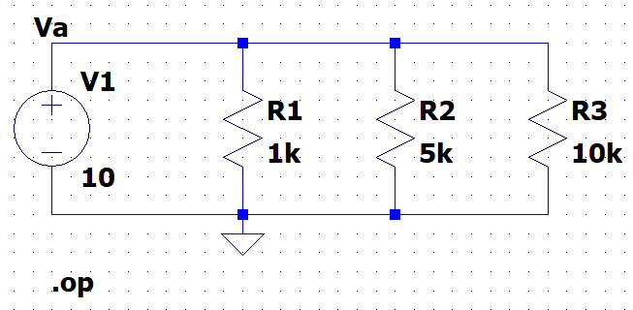

Verify CDR of this circuit by measuring each branch current, and then relating each branch current with the conductance of the resistor in each branch.

|  |  |
| --- | --- |
| I(R1) : I(R2) : I(R3) in mA |  |
| 1/R1: 1/R2: 1/R3 in mMoh |  |
| Simplified ratio in integers |  |
| CDR confirmed (Y/N)? |  |

**Optional – not graded**

**Op amp model installation**

We use opamp **LM741** for the schematics. Go to Canvas, or <https://www.ti.com/product/LM741> and download the PSPICE model. Unzip to obtain the LM741.MOD file. Move the file to the sub-circuit (sub) directory of the library (lib) folder of the LTspice program on your computer (see example below). When you build your opamp circuit, add the “opamp2” component to your circuit schematic and give it the value “LM741/NS”. Add a .include SPICE directive to use this opamp. Here, your opamp will be powered by ±15V power rails.

**Practice op amp circuit**

Build the following op amp voltage follower (buffer) circuit:

Notice the following important issues of the above circuit:

1) Select the Opamps 🡪 opamp2 symbol to be your opamp here.

2) Your opamp’s instance name is U1 (which is arbitrary – your choice of name). Your opamp’s value must be set to LM741/NS, which the name of the sub-circuit of the LM741 opamp model. Cntl-Right click on your opamp to set this opamp value.

3) The .include (or .inc for short) Spice directive lets you import the LM741 opamp model (which is the “LM741.MOD” file) to your circuit. Here the LM741.MOD file is placed at C:\Program Files\...\sub. Put the .MOD file in the sub-circuit directory of the library of the LTSpice program on your computer.

4) The opamp is powered by a +15V power rail and a –15V power rail. Here the label nets V+ and V- are utilized to make your opamp connection look neat. Using label nets like this can make your circuit appear clean and organized.

5) The source voltage Vs is being DC-swept from -15V to +15V, which is the two power rail voltages. In general, a voltage follower (buffer) lets the output voltage Vout follow the input voltage Vin, but there is a limit to this voltage-following behavior. What is this limit? Probe the Vout node to find out.

**Deliverables**

a) A concise lab report including: objectives; brief description of methods; conclusion

b) A collection of all the data tables – as an appendix to your lab report

c) All the LTspice circuit files (.asc files) in one zip file to upload to Canvas

d) Optional, not graded – Tinkercad (snipped image of each circuit)

**Summary of data tables**

**Circuit 1_1_1**

|  |  |
| --- | --- |
| V(R1) : V(R2) in Volt |  |
| R1: R2 in kOhm |  |
| Simplified ratio in integers |  |
| VDR confirmed (Y/N)? |  |

**Circuit 1_1_2**

|  |  |
| --- | --- |
| V(R1) : V(R2) : V(R3) in Volt |  |
| R1: R2: R3 in kOhm |  |
| Simplified ratio in integers |  |
| VDR confirmed (Y/N)? |  |

**Circuit 1_2_1**

|  |  |
| --- | --- |
| I(R1) : I(R2); unit is in mA |  |
| Ratio of 1/R1 : 1/R2; unit is in mMoh |  |
| Simplified ratio in integers |  |

Write down the current division rule (CDR)

|  |
| --- |
|  |

If the current value is negative, explain the cause:

|  |
| --- |
|  |

Use a voltage source as a hack multimeter to measure the current of a resistor. Apply this trick to measure both I(R1) and I(R2). Attach a screenshot of your circuit with these hack multimeters:

|  |
| --- |
|  |

**Circuit 1_2_2**

|  |  |
| --- | --- |
| I(R1) : I(R2) : I(R3) in mA |  |
| 1/R1: 1/R2: 1/R3 in mMoh |  |
| Simplified ratio in integers |  |
| CDR confirmed (Y/N)? |  |